OVERLAPPING CLIMATE POLICIES (Perino, Ritz, van Benthem)
The Economic Journal 135
https://academic.oup.com/ej/article/135/671/2122/8111601?login=false

Policies enacted by individual subjurisdiction in a context of pre-existing policy (e.g. coal power plant phase-out, or Spain’s large scale renewable support programme, occuring within EU ETS).
How do “overlapping policies” help reduce global emissions ?
The effect depends on 1) product market effects ; 2) carbon market effects

1) Product market effects : i.e. within-market inter-subjurisdiction substitution
For instance, a successful sub-jurisdictional emissions reduction policy like coal phase-out may increase electricity prices even as domestic emissions are reduced, pulling in further electricity imports (which may be itself coal-generated, offsetting the emissions allowance demand drop from the coal phase-out).

2) Carbon market effects : i.e. effects stemming from allowance supply price elasticity (which is 0 for fixed cap systems, non-zero for e.g. price corridor systems; a carbon tax implies infinitely elastic allowance supply).
Suppose that product market effects do end up in a net reduction in allowance demand from the concerned sector : for instance coal is replaced by imports of clean energy.
- If allowance supply is fixed, the reduction in emissions merely triggers a reshuffling of allowances : the reduced allowance demand translates to lower allowance prices, and thus other sectors can pollute more.
- The basic fixed allowance supply story is complicated by 1) most cap systems are effectively hybrid ; 2) many allow intertemporal banking.
In practice, the carbon market effects will rarely net out any other emissions reduction effects (i.e. overlapping policies can contribute to emissions reduction!)
Implications :
Product market effects correspond to shifts in allowance demand ;
Carbon market effects correspond to responses of allowance supply;
For any given subjurisdictional policy, its effect on overall emissions will depend on 1) and 2).

Other results :

- On “internal carbon leakage” :
- Policies that reduce supply of “dirty” products have high leakage (can be an increase in price of carbon or mandated output reduction like a coal phase-out) : other subjurisdictions, in reaction to the drop in output and allowance demand, will “fill the gap” left by the product supply reduction. A net increase in emissions is even possible if enough susbitution or the substituting producer’s technology is dirty enough.

- Policies that increase demand of “clean” products (renewables support, promotion of energy efficiency) have low leakage : these policies reduce demand for the dirty products, thus their price, and thus output+emissions from other subjurisdictions.

- “Waterbed” or carbon market effects :

The paper abstracts from effiency or welfare or cost-effectiveness considerations, esp in terms of the fiscal side of policy.

Model/framework :

With a classical cap-trade system in mind, denoted “ETS” :
Tau = carbon price
E_i = demand for allowances in jurisdiction I ; assume that dE_i < 0, i.e. policy successfully reduces local emissions/allowances demand.
dE = aggregate emissions demand.

Concept : Internal carbon market leakage : emissions displacement from a policy change in I aimed at a specific sector, within a cap-trade system with given tau (system-wide carbon price)
L_i = (-dE_j/dE_i), for a given fixed tau.
Aggregate allowance demand: dE = de_i+de_j+dÊ, with dÊ = changes in allowance demand in sectors not targeted by the specific overlapping policy (set to 0 for exposition).
dE = (1-L_i) dE_i (for fixed tau) dE = [1+(dE_j/dE_i)]*dE_i

Concept : Waterbed effect, the emissions effect of the response of carbon price (via allowance supply).

W = 1-dE*/dE (tau endogenous) where dE* is the aggregate equilibrium emissions for a system-wide carbon price tau (here assumed endogenous).
With a fixed cap, dE* = 0 and so W=1. A carbon tax would have W=0 and dE* = dE.
In reality, typically W in [0;1] with cases of W <0 or W > 1.
(NB : the paper refers to dE as change in allowance demand but dE* as change in equilibrium emissions).

The framework in 1 equation :

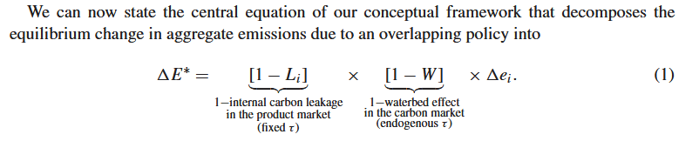
Denote R = (1-L_i) * (1-W) the effective emissions reduction rate of an overlapping policy.
R may be 0 for very different reasons : L_i = 1 implies a product market-specific issue ; W= 1 implies need for a reform of the carbon market system (or abandoning any overlapping policies).

Supply-side policies
If country i raises carbon price unilaterally :
Producer from i faces a country-specific increase in carbon price ; the sign of leakage depends on the output response of producer from k to the increase in price for producer from i.

If country I reduces emissions unilaterally
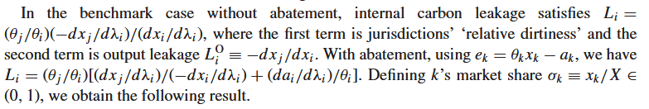
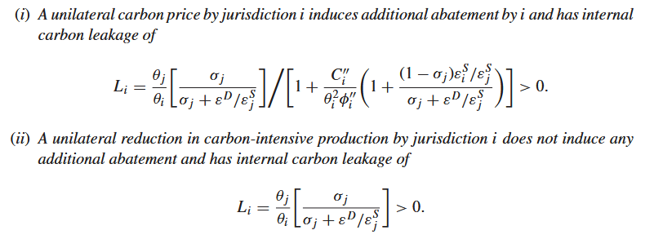

Supply-side overlapping policies always have negative internal leakage : domestic output response is negative (due to mandated output reduction or carbon price increase).
Output leakage is always <100% but carbon leakage may be >100% if the substituting firm is sufficiently dirtier.
For a cut in polluting output :
Leakages are more pronounced if firm j has high market share ; demand is price inelastic ; firm j has high supply elasticity (eg spare capacity) -> these all determind output leakage, which is then scaled by theta_j/theta_i. (ratio of abatement costs).

For a rise in carbon price :
Leakage can be mitigated by abatement, which breaks the output-> carbon leakage direct link; this depends on the marginal abatement cost curve’s slope (if near-flat, abatement is easy and leakage near 0 ; if abatement is infeasble, ie carbon enters in a Leontief-like function, carbon leakage is identical to the polluting-output-reduction policy.)
For any W [0;1], R <1 and supply-side overlapping policies are substitutes.
Demand-side policies :

Examples of policies that reduce demand for carbonated production : support for renewables, energy efficiency, carbon-consumption tax…
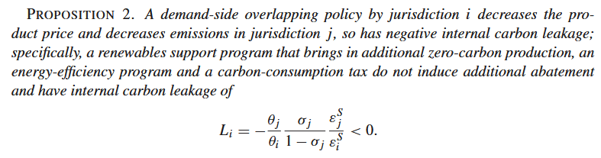
(recall sigma_j is the market share of firm j, x_j/X)
The negative leakage stems from firm j’s exposure to the policy in i : the reduced demand feeds into its own production decisions.
“Flip-side” of the merit order effect whereby near-0 marginal cost renewables reduce wholesale power prices.
Similarly to supply policies, the leakage will be greater if firm j is dirtier ; has more market share; is more elastic in terms of supply.
Demand characteristics do not feature – production of firm I and j will both respond according to the partial derivative of product demand to the policy’s “stringency factor”. (recall that L relates to the relative magnitude of emissions changes in j and i).
For any W [0;1], demand side policy is complementary :R >1
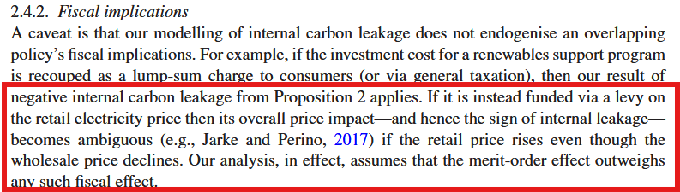
Abrell et al (2019) find that renewable support leads to negative leakage ; controlling for “levy-based” funding of renewable support, retail electricity prices decline for wind but rise for (more costly) solar : funding of abatement cost can significantly impact the leakage of renewable support or demand side policies.

“In sum, our results imply that, if a supply-side policy and a demand-side policy both lead to the
same domestic emissions reduction, the latter policy translates into a larger reduction in aggregate
emissions (as long as W < 1). However, as the above arguments make clear, the details on how
abatement costs are recovered for demand-side policies, and how revenues are redistributed for
supply-side policies, have the potential to affect the leakage ordering between these two types
of policies. Choices about cost recovery and revenue redistribution are therefore also an integral
part of climate-policy design.”

Carbon market effects (Waterbed effect)

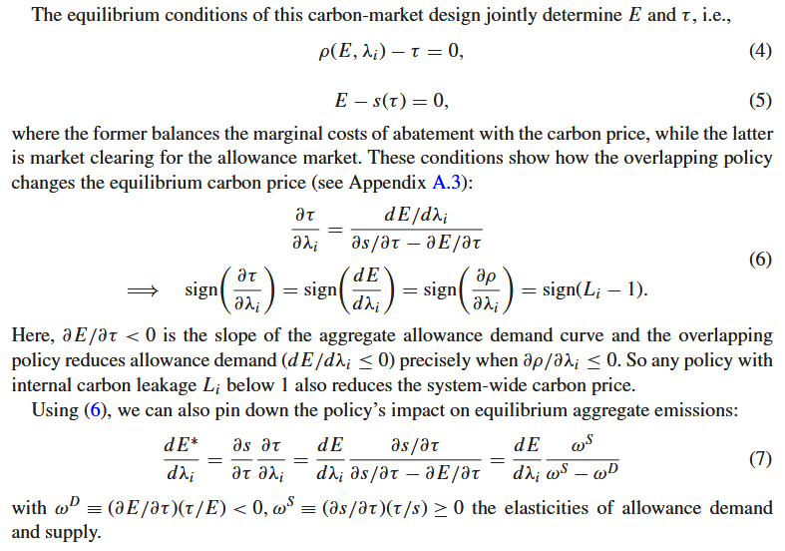
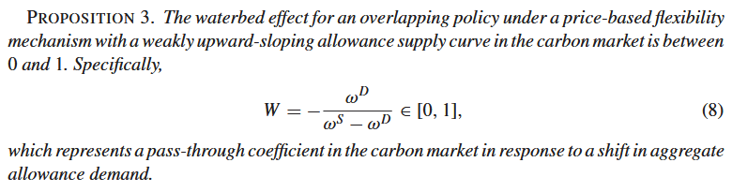

- W depends on the policy only insofar as it affects allowance demand elasticity ; (sign and intensity of L do not feature explicitly)
- The result is akin to the classical tax incidence under perfect competition of an excise tax passthrough to consumers (tho not strictly the same, i.e. 1-m).
- W reflects a pass through coefficient to consumers ; “the rate of price adjustment in the carbon market due to a downward shift in allowance demand induced by an overlapping policy”.

Note that these are marginal effects, so for large policy changes -> need to integrate over marginal effects.

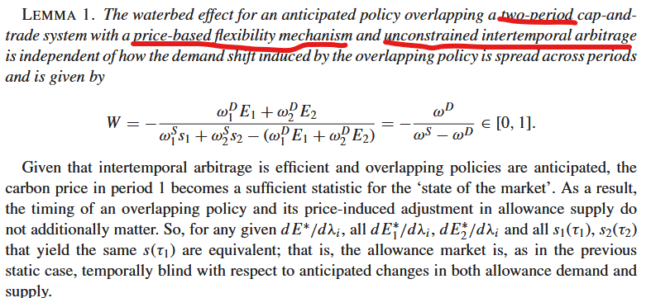

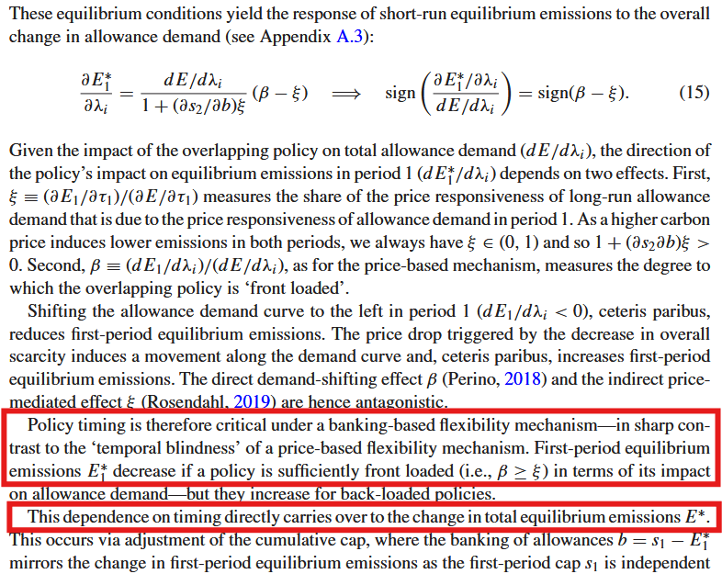

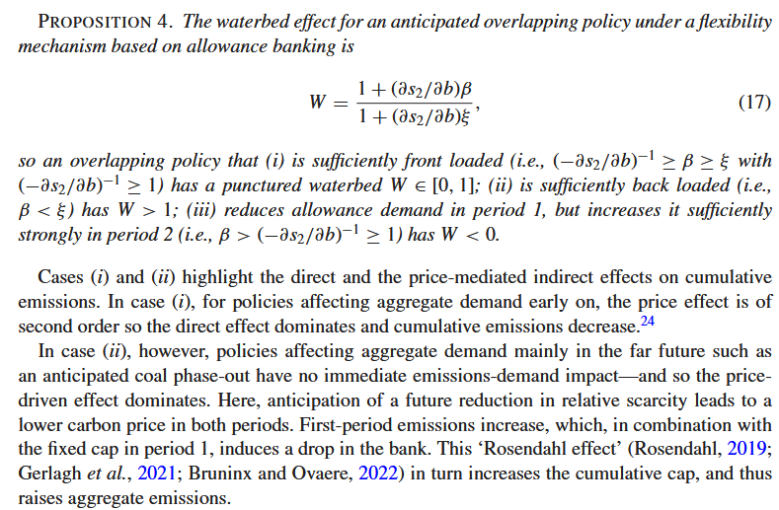

Bridging the Energy Efficiency Gap: Policy Insights from Economic Theory and Empirical Evidence
Kenneth Gillingham and Karen Palmer
https://www.journals.uchicago.edu/doi/10.1093/reep/ret021

Energy efficiency gap : investments in higher efficiency equipments, appliances etc would yield positive net present value, in excess of upfront costs, yet consumers in reality do not take up such investment opportunities.
Seemingly related to a higher time discounting of future energy savings, or underweighting of these savings/of energy efficiency attributes.

- Energy efficiency related decision making deviates from estimates of NPV, and implies that social diffusion of these technologies is slower than optimal.

Yet there is plenty of criticism of the “energy efficiency gap” :
“Economists have long recognized that market failures including environmental externalities, inefficient pricing of energy, lack of information, and principal-agent issues can lead to inefficiently low levels of investment in energy efficiency”.

Some economists also point to systematic behavioural biases in consumer decisions.

What size is the gap ? Critics argue on revealed preferences above engineering-based estimates of the savings’ value vs cost of improvements, i.e. taking into account frictions, hidden costs etc, the NPV of improvements is lower.

Hidden costs :
Admin costs of efficiency programmes ; time sunk in finding/installing new equipment ; opportunity costs (eg more efficient lightbulbs but with less pleasant lighting). Note that the latter, i.e. quality/opportunity costs, are hard measure and require evaluation on a case by case basis.

Consumer heterogeneity :

Apparent gap might be lower in reality due to heterogeneous preferences, usage of appliances (eg AC for summer home vs permanent residence), cost of borrowing..
Possible selection bias, i.e. consumers with higher weight on future savings already select more efficient equipment.

Uncertainty:

Efficiency investments carry risk due to their irreversible nature vs volatility of energy prices. Some studies show that incorporating uncertainty leads to 4x-5x higher required rates of return ; others claim the results are specific to set up (ie not generalisable to multiple choices of efficiency technologies).

Uncertainty may also concern the equipment’s performance in themselves.

Engineering studies may also overestimate savings : for example by insufficiently taking into account interactions (heating & lighting), or simplifying assumptions (perfect installation + maintenance of the equipments).

Market failure explanations for the EE gap :

Imperfect information : if consumers don’t have full information about expected savings, then investment is disincentivised. Sellers may have superior information yet difficulty conveying it credibly -> asymmetric information.
Information imperfections increase apparent risk of investments (this may play a role especially in firms’ decisions).

Principal-agent issues: landlord pays for heating but tenant decides consumption ; landlord decides on energy efficiency, which the tenant can only imperfectly observe.
Some evidence that such issues increase energy use/reduce efficiency, but the estimated magnitudes are small.

Credit constraints : High upfront cost investments can be prohibitice to households if access to credit is limited. Can be classic credit rationing – lenders esp may have a hard time assessing the value of an improvement’s savings (i.e. distinguishing high/low payoff investments).

Regulatory failures : if price distortions bring energy prices below marginal cost, then the regulatory context may contribute to the energy efficiency gap. (but as customers tend to prefer fixed prices, eg intraday price levels tend to be higher than efficiency prices – cf off peak hours).

Behavioural anomalies & failures

NB : to provide a satisfactory explanation, these must be systematically biased towards lower efficiency products.
Anomaly = behaviour departure from standard assumption ; failure : anomalies leading to a systematic difference between decision and experienced utility.
Systematic intertemporal biases :cf decision (utility as computed at time of decision) vs experienced utility (realised utility).

The following are anomalies :

Nonstandard preferences :
- Self-control problems : preferences appear time-inconsistent. Seemingly long-term view towards decisions for far-off future, yet behaviour is more akin to discount rate increasing as the relevant future approaches.
- Reference-dependent preferences : decision making under uncertainty, where payoff depends on reference point. Eg for loss aversion, reference point is <0. If energy prices are uncertain, (and equipment performance and/or usage as well, eg for a new car), then loss aversion may contribute to underinvestment.

Systematically incorrect beliefs ? Surveys seem to show that consumers have difficulty forecasting values of savings but are not systematically biased.

Nonstandard decision making ?
- Limited attention : systematic underweighting of info is one of the recurring pro-gap arguments. Typically consumers will assess car fuel efficiencies using simple heuristics.

One of the more important consequences of deviations from standard consumer decision theory arising from behavioural features is that the computation of welfare in models is complicated, since the assumptions (stability of preferences over time; full information ; indifference between various sets beyond the quality of said sets, i.e. no “framing effects”) upon which rest the estimation of revealed utility function parameters are violated.

Policies for market failures :
For eg environmental or energy security externalities, a Pigovian tax is the clear first-best. Some other market failures aren’t as straightforward to address : eg information failures may not be remedied by simply providing the information to agents (landlords/tenants in a previous example). Credit rationing can be addressed through government financing programmes, but it’s not clear if targeting can be implemented.

Empirical evidence

Information assistance, which include low/no-cost energy auditing : by themselves, these programmes have limited effects on household decisions. (may be different for firms).

Economic incentives : rebates, tax incentives, low-cost loans..

Debates over subsidies.
- They require financing ; often this will involve a distortionary tax.
- May cause rebound effects.
- Inframarginal, aka “free riding” consumers.

EEOs in practice represent a combination of information assistance + rebates & other financial incentives.

Assessing the energy-efficiency gap (2015)
Richard G. Newell, Robert N. Stavins, and Todd D. Gerarden1
https://www.hks.harvard.edu/sites/default/files/centers/mrcbg/files/mrcbg.fwp.2015-04.Stavins.efficiency.pdf
Very simplified model of energy efficiency cost-minimising problem :
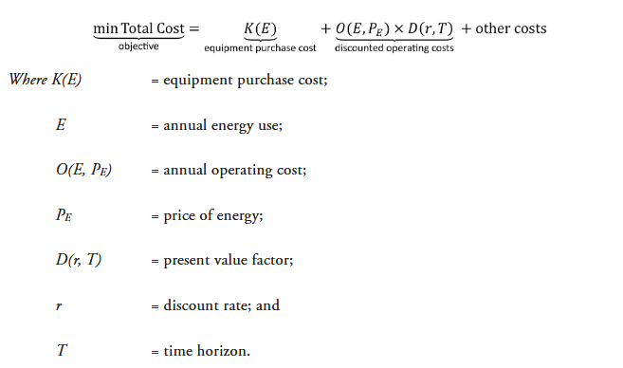

On the optimal energy efficiency levels of products offered by firms : there is little empirical evidence (mostly on cars), but theoretically firms can provide too much/too little efficiency.
- Firms respond to marginal valuation of quality, whereas social optimum refers to average valuation ;
- Eg carmarkers making cars “too” efficient on their product segment of efficient cars, and not efficient enough at the lower end of the quality spectrum. This type of strategy allows to extract consumer surplus according to their tastes while minimizing chances of “defections” to other products.
Labelling policies etc may have unintended consequences, for example consumers may be willing to pay more for an “eco-friendly” label of sorts.

There may also be a tension between optimal innovation (which presumably involves high fixed costs and thus above marginal cost pricing) and innovation diffusion speed (favoured by low prices).

On both above dimensions the energy efficiency market per se does not display remarkable characteristics that warrant a highly market-specific model.

Deviations from cost-minimisation problem ?

“The empirical evidence ranges from strong (split incentives/agency issues and inattention/ salience phenomena) to moderate (heuristic decision-making/bounded rationality, systematic risk, and option value) to weak (learning-by-using, loss aversion, myopia, and capital market failures)”

--

CAPM : using it as a framework, and based off suggestive empirical evidence that fuel prices exhibit a negative correlation to the stock market, energy efficiency investment could have a lower discount rate/hurdle rates than initially though.
OTOH, the CAPM is a static portfolio allocation model : in reality, the investment choice set, expected returns, and investment covariances are time-varying. Furthermore, transaction costs are far from zero (if there even is a secondary market), investors aren’t very diversified, and CAPM fails many empirical tests.

Option value—the net benefit of delaying an investment even when the investment’s net present value is positive—is a general feature of dynamic optimization problems with uncertainty, irreversible investment, and timing flexibility (Dixit and Pindyck 1994).
- Often applies to consumers having to make irreversible (i.e. very little resale value) decisions under uncertainty.
- Option value, that is the value of waiting, is likely to be enhanced by uncertainty over energy prices and future technological innovations.

But 4 assumptions are required :

- Irreversibility : there may be resale markets, [or the investment’s value may be capitalised]
- Uncertainty : mitigated by long term energy contracts (esp for firms), short lifetime of the good (eg light bulb) ;
- Flexible timing: in fact investment timing may not be discretionary (replacing a broken appliance).
- Lumpiness of investment.

https://www.journals.uchicago.edu/doi/epdf/10.1093/reep/ren005

Max cost-effectiveness -> all agents face same marginal price on emissions
Max efficiency -> marginal emissions price level equalises marginal abatement cost and benefits.
In practice programmes target sectors etc when trying to set an identical marginal price on emissions.

Emissions abatement subsisdies are akin to emissions tax/cap+trade : firms are rewarded for every abatement below a baseline emissions level.
However, they are typically less cost-effective : by reducing firms’ average costs, they incentivise excessive output and entry. For a given emissions target, subsidies will emphasise input substitution etc abatement, rather than lower output.

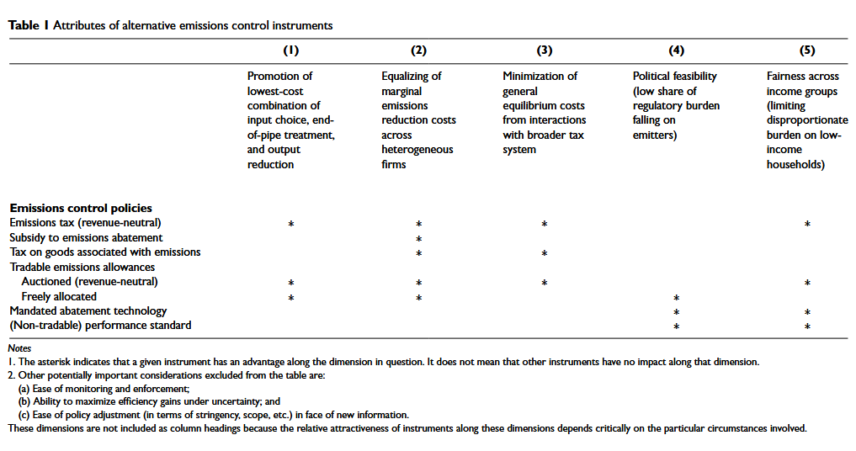

Taxes on goods associated with emissions : fuel, air travel, electricity etc. May be attractive if difficult to monitor emissions directly. But, since they do not focus on the externality per se, they don’t engage all reduction channels, and therefore aren’t the most cost-effective. (Eg reducing electricity demand/output but not encouraging clean input substitution).

Output reduction channel is a substantial part of incentive-based instruments ; if product prices move little, then part of the instruments’ cost-effectiveness advantage disappears.
Combinations of instruments may be fruitful : eg fuel emissions standards imposed on carmakers (=enforced input substitution)+ gasoline tax approximates a car emissions tax (output channel, ie mileage driven).

Efficient recycling of raised revenue matters for the overall efficiency of incentives.

https://link.springer.com/article/10.1007/s10640-007-9110-y
4.4 -> tax + subsidy can be a useful instrument combination, approximating a Pigovian tax, in cases where the relevant behaviour is difficult to observe.
Eg recyclables: a Pigovian tax would tax improper disposal of recyclable material (aluminium can) ; instead one can tax purchase of such recipients, and offer a subsidy for proper recycling.
For cars : efficiency standards + gasoline tax, or even a combination of fuel, engine size, car age taxes.
The use of multiple instruments implies that they are carefully considered and well-coordinated; outside of the area of waste management, i.e. deposit-and-refund polcies, such purposeful combinations of instruments are uncommon.

In the case of uncertainty : if av of slope of marginal cost > marginal emissions reduction benefit, then price instrument, otherwise quantity instrument.
If multiple instruments possible : a combination of price & quantity, as both instruments provide protection against the worst outcomes of the other. Quantity instruments protect vs too high pollution, taxes provide incentives for reductions beyond quantity targets if the costs are low.
So eg a permits system with subsidies for excess holdings and taxes on emissions if these are higher than held permits.

